Metaballs
Create Organic Meshes

Ideal for creating new and organic looking base meshes that can be tweaked with Mesh Editor.

Starting Metaballs
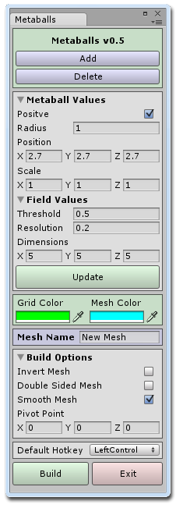
To start using Metaballs click on the Window menu item, scroll down to the Metaballs item and then click on Open Window.

When the window opens you will notice that a new object called Metaball has been added to the hierarchy. This item is the green wireframe cube that appeared in the scene view window. You can move it around and rotate it like a normal object. The sphere at the center of the green box is the first metaball which has been created for you.

The Update Button

At any time you can click on the Update button on the Metaballs window to update the metaballs within the cube. If you have made changes and the scene view hasn't updated automatically then try clicking on the Update button.

Selecting and Moving Metaballs

To select a metaball click on its handle (small white square) at the center of the metaball and that metaball will become the active metaball. When selected you can move the metaball around within the cube by dragging its handles to a new position. If the metaball is moved to a position outside the cube then it will not be rendered. You can also change the position of the currently active metaball by changing the position values in the window under Metaball Values. To select a group of metaballs simply hold down the hotkey (left control key by default) when selecting their handles. The handles will turn green to indicate that they are a part of the group.

Adding and Deleting Metaballs

You can click on the Add metaball button at any time and a new metaball will be added at the center of the cube. If metaballs overlap then all you will notice is that the size of the overall shape increased. This is because the two metaballs are both contributing to the shape at that point. Clicking on the Delete button will remove the currently selected Metaballs.

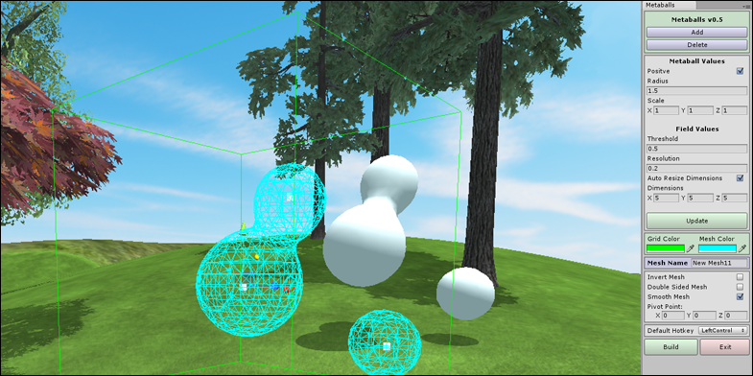

Positive and Negative Metaballs
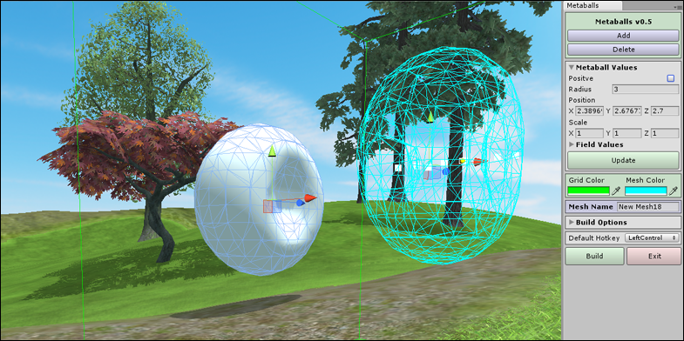
By default all metaballs are created with a positive influence on the shape. Each positive metaball will add to the current shape. You can set the metaball to have a negative influence by un-checking it in the window under Metaball Values. This will change the state of all metaballs in a group.

A negative metaball will have the effect of reducing the shape size or cutting out a piece of the shape in its area of influence.

Radius and Scale of Metaballs

You can change the radius or scale of one or more metaballs at a time by changing their values in the Metaballs window. With careful use of these you can achieve very interesting and detailed shapes.

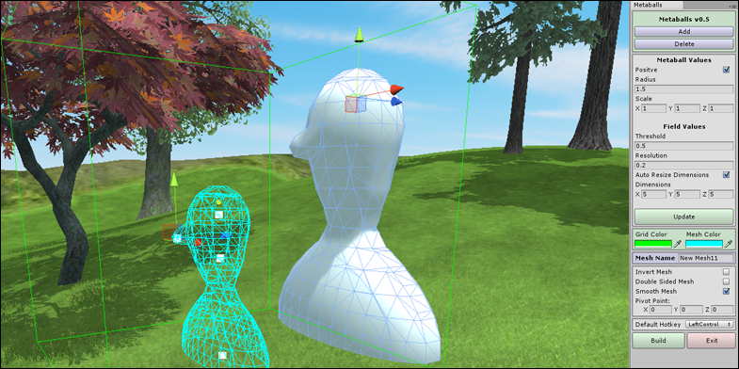

Field Values

Just below the Metaball Values are the Field Values. You can open the foldout section by clicking on the small arrow next to the title.

Within the Field Values section you can change the dimensions of the cube. Ideally the size of the cube should be no bigger than the surface of the shapes within it. By keeping the size of the cube small you will speed up the calculations when the metaballs are updated.

The Threshold value has the effect of decreasing the size of the shapes within the cube. While the Resolution will appear to increase the size of the shapes. By increasing the radius of a metaballs and decreasing the resolution you can improve the quality (higher triangle count) of the shapes created.

Colors

The default colors used for the cube and metaballs are Green and Cyan. You can change these to work in different lighting/background conditions by clicking on the color box or the color picker just below the Update button.

Mesh Name

Before building you can change the name of the final mesh. Meshes are stored in the Meshes folder within the main folder. If a mesh with that name already exists you will be notified before the mesh is created.

Build Options

When you open the Build Options foldout you will see that only the option for a smooth mesh is selected. You can also set the final mesh to be inverted, double sided or have a faceted appearance by turning these options on or off before clicking on the Build button.

Pivot Point Location

The small yellow sphere displayed at the center of the cube is the location of where the pivot point will be when the mesh is created. You can adjust this default location by changing the pivot point values and the final mesh will be built relative to this point.

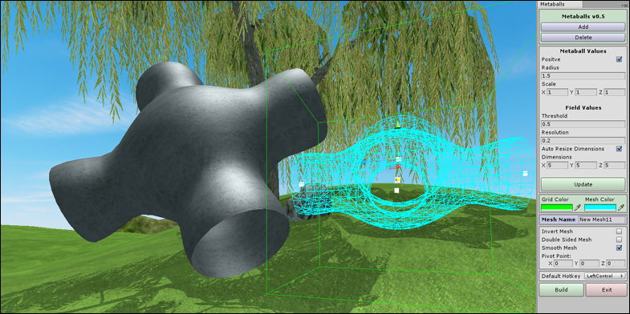
Building the Mesh

When you have everything positioned where you want and you have set the build options you can go ahead and create the final mesh by clicking on the Build button. The mesh file for the shape will be stored in the meshes folder.

Default Hotkey

The left control key used by default can be changed to another key by selected it from the dropdown list of keys.

Prefabs

Prefab objects are automatically created by default and placed in the main folder in a subfolder called Prefabs. You can change this behavior by un-ticking the first check box in the list.

To learn more about Metaballs and to view the tutorial videos you can visit
MeshMaker.com

